Cryptocurrency and the Blockchain
Target Audience: The target audience is prospective investors who wish to diversify their current investment portfolios by learning about digital currency, blockchain technology, and how to invest.
Learning Objectives:
- Define the purpose and use of cryptocurrency and the blockchain
- Identify types of blockchain technology based on their use cases
- Assess viable cryptocurrency storage options
- Estimate best tax options based on digital currency utilization
Outline:
- Course Intro / Navigation / Objectives
Topic: Cryptocurrency and the Blockchain
- Defining the Block
  - Block image appears represents a singular digital transaction along with explanation of a block/singular transaction
- Defining the Blockchain
  - Image of blockchain or connected blocks (appears next to block image demonstrating correlation between the two.) Explanation of blockchain and cryptocurrency
  - Imbedded video of motion and code depicting the blockchain in a visual manner.
  - Knowledge Check: Blockchain
Topic: Varieties of Digital Currency (tabs)
- Digital Currency Tab Triggers Slide
  - Scene: Five (5) Cryptocurrency Types
  - Select each of the five (5) tab tabbed topics to reveal information:
    - Bitcoin
    - Ethereum
    - Cardano
    - Ripple
    - Dogecoin
  - Knowledge Check: Bitcoin
Topic: Use Cases for Digital Currency
  - Three images accompanied by video trigger showing three use cases in action
    - Purchase
    - Gaming
    - Metaverse
  - Each summarized under photo
  - Knowledge check: Purchase
Topic: Use Cases for Digital Currency
  - Three images accompanied by video trigger showing three use cases in action
    - Purchase
    - Gaming
    - Metaverse
  - Each summarized under photo
  - Knowledge check: Purchase
Topic: Why Consider Digital Currency as an Asset
(Slow reveal of each sliding overlay trigger over motion graphic)
  - Viable option for investors to create and build wealth
  - Seen by investors as the currency of the future
  - A value that has yet to be determined
  - Speculative nature of the tokens makes it a commodity
Assessment: Four (4) knowledge checks presented during the presentation to check learners understanding. Post-Assessment at the end of the presentation with five (5) questions to determine learners overall understanding of the entire course. 80% passing on e-learning post module assessment. Learner has two opportunities to attempt each question with feedback for every module question.

Directions: [Besides a menu tab that identifies the slide progression as learner progresses through the module, a glossary tab is available for the learner to reference all terms.]
Style Notes: Storyline presentation, Agency FB Font, Well-Said Labs Audio for Narration, Pixabay, Adobe Stock, Unsplash for images.

Scene 1 Getting Started
Slide [1.1]/ Menu Title: Cryptocurrency and the Blockchain |  |  | Objective: [#]
Visual / Display: | Slide Text: | Narration / Voiceover: | Animation / Interaction:
This background will be used:  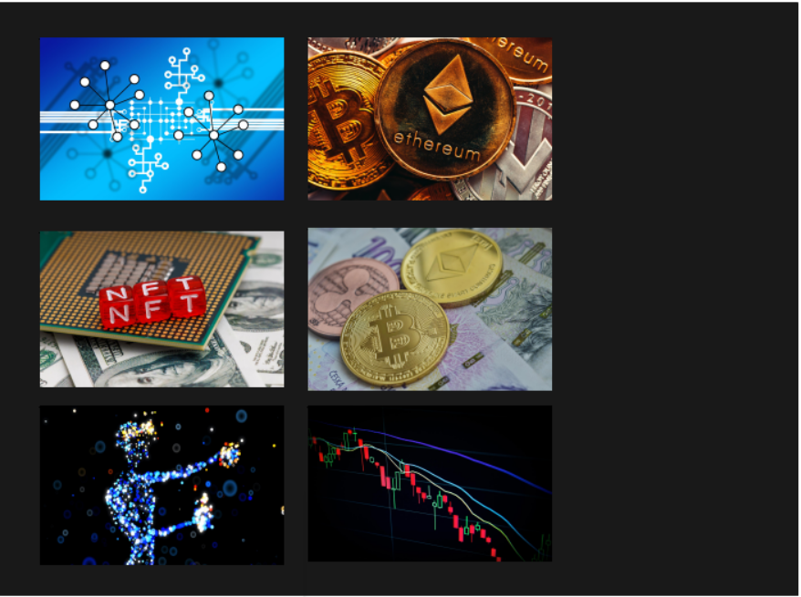 | [1] Cryptocurrency and the Blockchain  [2] Introductory Course  [3] Course Navigation [button]  [4] Start [button] | [1] Welcome to the eLearning course Digital Currency and the Blockchain.  [2] Before we begin, if you would like information on how to navigate the course, select the Navigate Tutorial button.  [3] If you are ready to jump right in, select Get Started. | Once slide begins, the Cryptocurrency and the Blockchain (top right of slide) and Introductory Module title (bottom below bitcoin image) appear through use of a simultaneous motion path.  COURSE NAVIGATION Button appears under the title using fade animation.  GET STARTED Button appears under the Course Navigation button using fade animation.  Learner selects GET STARTED button to advance to slide 1.3.  Learner selects COURSE NAVIGATION to advance to slide 1.2.
Notes: Introductory slide for the eLearning module with a visual display of various images that relate to the distinct types of blockchain technologies mentioned in the module including cryptocurrency, NFTS, blockchain. Two buttons enable learner to choose whether they wish to review course navigation tools prior to beginning the course.

Slide [1.2]/ Menu Title: Navigation Slide |  |  | Objective: [#]
Visual / Display: | Slide Text: | Narration / Voiceover: | Animation / Interaction:
This background will be used: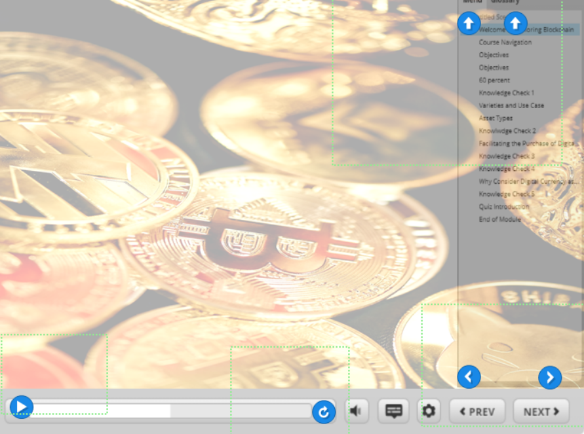 | Menu Tab | [1] To move back and forward, simply press the previous or next button.  [2] If you want to see something again, select the refresh button.  [3] If you want to pause the course, select the pause/play button.  [4] If you want to navigate the course, view the menu tab.  [5] If you wish to review the terms and definitions throughout the course, select the glossary tab.  [6] So, let’s get started. [7] Select the next button to continue. | Individual markers with button images automatically appear on top of each button and tab. Markers zoom in and pulse upon mention in narration:  • Play button  •Repeat button  •Next Button  •Previous Button  •Menu Tab  •Glossary Tab  Upon completion of narration, pulsing markers are in hidden state as the next button appears so the learner can advance the slide.
Notes: Navigation slide is optional for learner based on prompts on introductory slide.

Slide [1.3]/ Menu Title: Course Overview |  |  | Objective: [#]
Visual / Display: | Slide Text: | Narration / Voiceover: | Animation / Interaction:
This visual will be used:  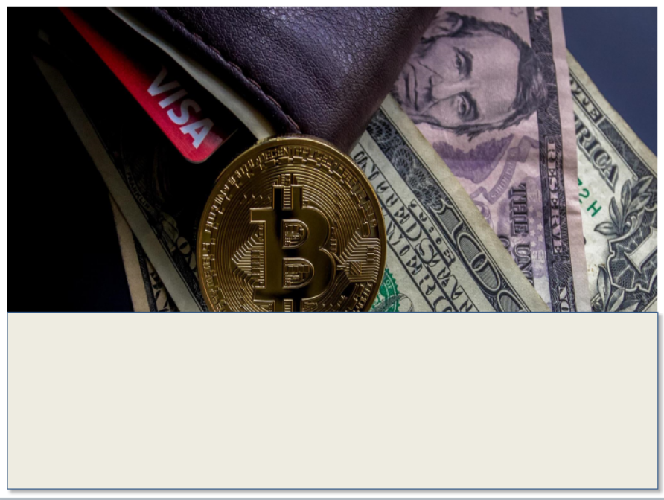    Introduction to Cryptocurrency and the Blockchain  Introduction to Cryptocurrency and the Blockchain  Each circle shape begins as green and turns blue when mentioned in narration. Text under the circle is highlighted in white upon the circle turning blue. The circle returns to green after the narration completes for each individual topic.  The next button appears upon the completion of narration. | Course Overview  1.Cryptocurrency and the Blockchain  2. Varieties and Use Cases  3.Financial Exchanges  4. Cold Wallet vs. Digital Wallet  5. Digital Currency and Taxes | [1] Course overview.  [2] This introductory online training is for those who are interested in learning the basics of digital currency.  [3] This course consists of five lessons  [4] Lesson one, introduction to cryptocurrency and the blockchain.  [5] Lesson two, varieties and use cases.  [6] Lesson three financial exchanges.  [7] Lesson four cold wallet vs. digital wallet.  [8] Lesson five, digital currency and taxes. | Once slide begins, the Course Overview title (top center of image) appears through use of a motion path.  The slide includes small green numbered circles, five (5) in total, along the white space. Each has the topic summary written underneath and appear individually through fade animation upon after the course overview title appears.  The circle shapes have hover states above each eLearning topic. The hover state/trigger changes the circle’s color from green to blue and simultaneously highlights the text under each in white to emphasize each topic as it is mentioned in the narration. Each circle returns to the green color and the white highlight is hidden after being introduced in narration.
Notes: All slide titles and labels will have a green background, like the green color in the animation circle.

Slide [1.4]/ Menu Title: Objectives |  |  | Objective: [#]
Visual / Display: | Slide Text: | Narration / Voiceover: | Animation / Interaction:
This background will be used: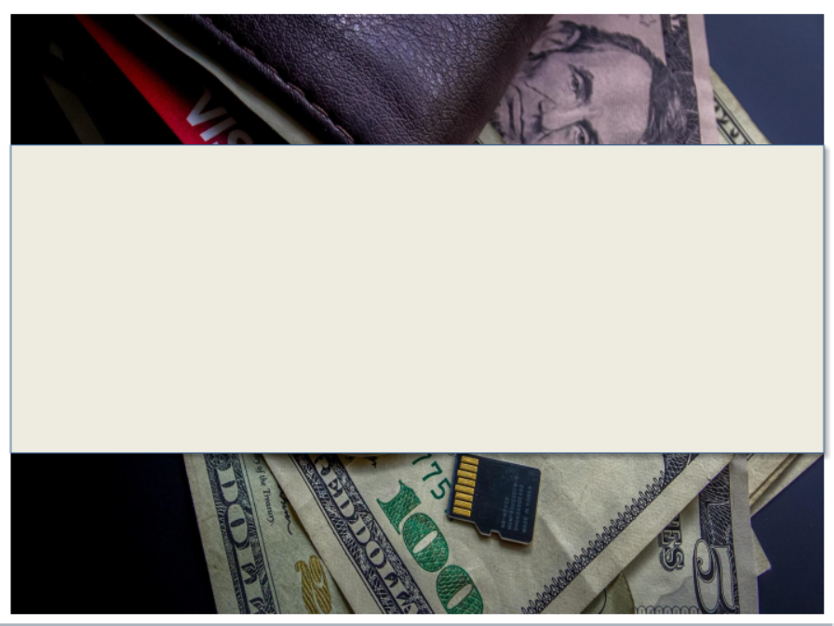 | Course Objectives  [1] Define the purpose and function of cryptocurrency and the blockchain.  [2] Assess digital currency types based on their use cases.  [3] Determine viable cryptocurrency storage options and  [4] Estimate the best tax options for digital currency utilization. | {1} At the end of this course, you will be able to [2] define the purpose and function of cryptocurrency and the blockchain  [3] Identify types of blockchain technology based on their use cases  [4] Compare cryptocurrency storage options, and  [5] Recognize best tax options based on digital currency utilization | Once slide begins, the Course Overview title (top center of image) appears through use of a motion path.  Objectives are staggered on the timeline to appear along the cream rectangle space, one at a time, as it is stated in the narration.  Slide trigger enables slide 1.4 to automatically advance to slide 1.5 upon completion of narration.
Notes:

Slide [2]/ Menu Title: [Cryptocurrency and the Blockchain] |  |  | Objective: [1]
Visual / Display: | Slide Text: | Narration / Voiceover: | Animation / Interaction:
  Slide background (double layer people scene and infinity symbol) with block and blockchain iconImbedded blockchain video image on top of slide background | [1] Cryptocurrency and the Blockchain  [2] Blockchain is a record of transactions, made in crypto, maintained across computers. Each transaction is called a block.  [3] Each block is connected to the previous block creating a network of transactions on a digital ledger called a blockchain.  [4] Cryptocurrency is a tokenized digital currency. The unit of account, purchases, and sales are recorded on the blockchain as tokens.  [5] The blockchain is decentralized, or not necessarily reliant on banks or exchanges for transactions to be make or for currency to be created, bought or sold | [1] Cryptocurrency and the Blockchain  [2] Blockchain is a record of transactions, made in crypto, maintained across computers. Each transaction is called a block.  [3] Each block is connected to the previous block creating a network of transactions on a digital ledger called a blockchain.  [4] Cryptocurrency is a tokenized digital currency. The unit of account, purchases, and sales are recorded on the blockchain as tokens.  [5] The blockchain is decentralized, or not necessarily reliant on banks or exchanges for transactions to be make or for currency to be created, bought, or sold.  [6] Think of the blockchain as a digital receipt of purchase, sale, and exchange. It is through the blockchain that digital and numeric imprints are made. These imprints keep a historical record of all cryptocurrency transactions made. (Video narration) | Once slide begins, the Cryptocurrency and the Blockchain title (top center of image) appears through use of a motion path.  Slide with timed animated random bar transitions of two layered images into a singular background image with transparent overlay adjustment. Begin audio narration.  Animation triggers in the bring in the shading and centered, text onto the screen, one paragraph of text at a time. Triggers are used to hide each block of centered text that appears after narrated before presenting the next in the script and narration notes. [1-4]  Two images appear. A block image appears at beginning [1] represents a singular digital transaction (block) along with a second image of a multiple transactions (blockchain) [2-4].  Narration [1-4] is completed, imbedded video will play and loop on the screen to show visual of the blockchain. Additional narration will run over video. [5]  Learner selects next button to continue.
Notes:

Slide [3]/ Menu Title: [Knowledge Check] |  |  | Objective: [1]
Visual / Display: | Slide Text: | Narration / Voiceover: | Animation / Interaction:
This is the background for this slide.  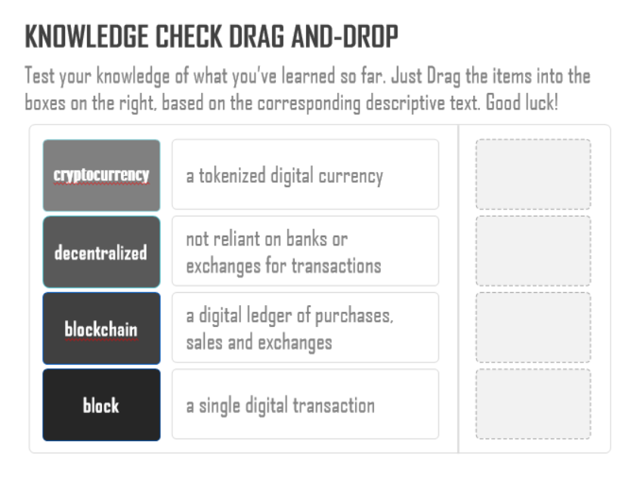 | [1] Knowledge Check  [2] Test your knowledge of what you have learned so far. Just Drag the items into the boxes on the right, based on the corresponding descriptive text. Good luck!  1.Cryptocurrency  2.Decentralized  3.Blockchain  4.Block  1.a tokenized digital currency  2. not reliant on banks or exchanges for transactions  3. a digital ledger of purchases and sales  4. a single digital transaction | Test your knowledge of what you have learned so far. Drag the items into the boxes on the right, based on the corresponding descriptive text. Good luck! | Question and answer choices appear in a static format on this slide.
Notes:

Slide [4]/ Menu Title: [Varieties of Cryptocurrency] |  |  | Objective: [2]
Visual / Display: | Slide Text: | Narration / Voiceover: | Animation / Interaction:
This is the visual for this slide: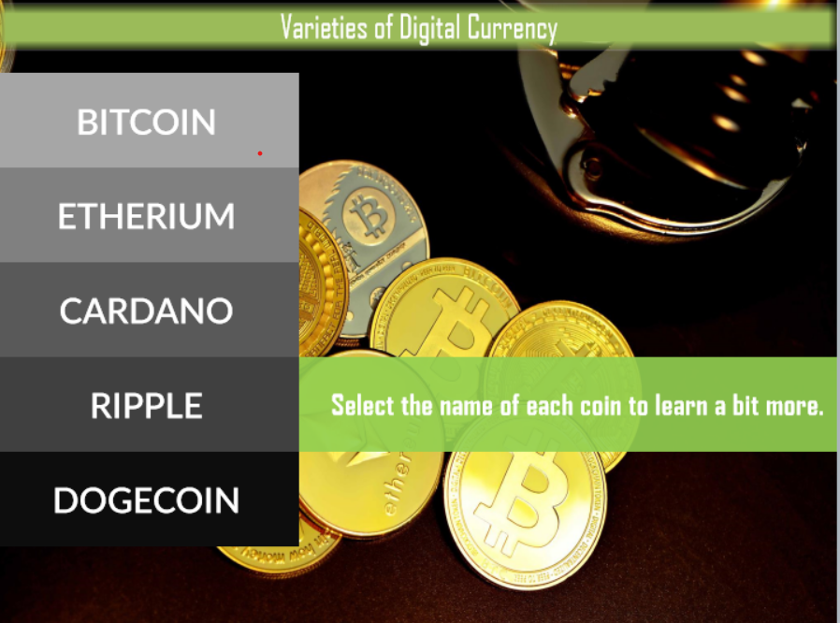  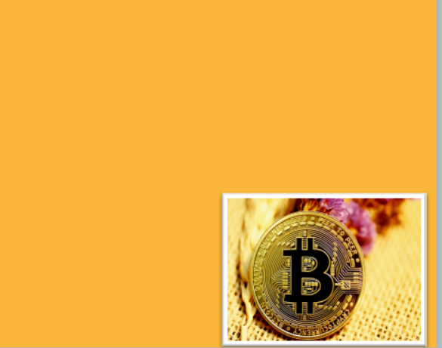  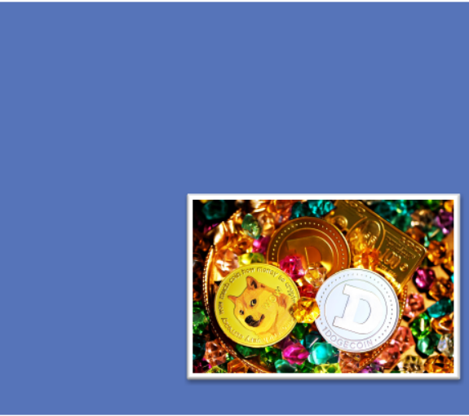  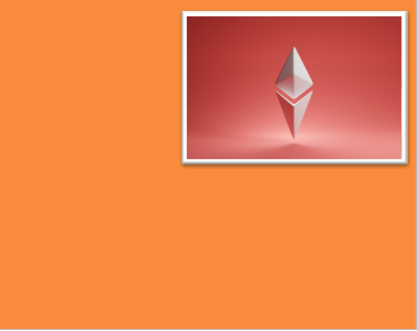     | [1] Varieties of Digital Currency  [Base Layer]  Bitcoin  Ethereum  Cardano  Ripple  Dogecoin  Select the name of each coin to learn a bit more.  [Bitcoin Layer]  Invented in 2008 by an unknown group of individuals under the pseudonym of Satoshi Nakamoto, Bitcoin is the first form of cryptocurrency. All other tokens are Altcoins or alternative coins in the cryptocurrency space.  [Dogecoin Layer]  Known as a “meme coin” or coin with little to know intrinsic value to the blockchain, the coin was named for an internet meme or humorous internet character. Dogecoin grew rapidly in popularity and value due to social media buzz and its development as a “joke” to make a play on the volatility and speculative nature of cryptocurrency.  [Ethereum Layer]  Ethereum, is second to Bitcoin in market capital. Ethereum is a native token to the Blockchain and is the catalyst for many smart contracts or transactions on the blockchain including NFT transactions.  [XRP Layer]  Digital coin designed specifically for global banks to utilize as their own transactional currency. Ripple has its own native coin, XRP. Designed to facilitate faster and cheaper payments, XRP enables secure global financial transactions and represents commodities and other units of value.  [Cardano Layer]  Cardano is a public blockchain platform that enables peer to peer transactions with use of its native cryptocurrency token ADA. Cardano is known as a proof of stake token meaning it has a specific way of verifying the validity of transactions on its platform by including pooled transactions in its verification process. | [1] Varieties of Digital Currency  [2] Let’s look at a few types of digital currency. Please note that this is by no means an exhaustive list but a few varieties. Select the name of each coin to learn more.  No audio on each coin layer. | Once slide begins, the Varieties of Cryptocurrency title (top center of image) appears through use of a motion path.  Five (6) layered tabs are added to the base layer of this slide. Each tab is set with slide animations once the slide appears. Each tab with a digital coin name can be selected and trigger each additional layer for a total of five (5) layers. Each layer is a different color and includes an image of the coin (as labeled on the tab) and a summarized description of the coin. There is currently no audio for each layer, other than the base layer.  Upon completion, the next button will appear, and the learner will advance to the next slide.
Notes:

Slide [5]/ Menu Title: [Knowledge Check] |  |  | Objective: [2]
Visual / Display: | Slide Text: | Narration / Voiceover: | Animation / Interaction:
This is the background for this slide: 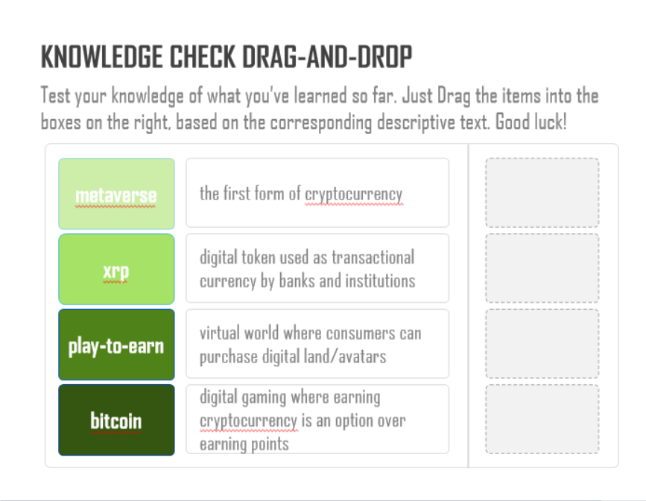 | [1] Knowledge Check  [2] Test your knowledge of what you’ve learned so far. Just Drag the items into the boxes on the right, based on the corresponding descriptive text. Good luck!  1.metaverse  2.xrp  3. play to earn  4. metaverse  1.the first form of cryptocurrency  2. digital token used as transactional currency by banks and institutions  3. virtual world where consumers can purchase digital land/avatars  4.digital gaming where earning cryptocurrency is an option over earning points | Test your knowledge of what you’ve learned so far. Drag the items into the boxes on the right, based on the corresponding descriptive text. Good luck! | Question and answer choices appear in a static format on this slide
Notes:

Slide [6]/ Menu Title: [Use Cases for Digital Currency] |  |  | Objective: [2]
Visual / Display: | Slide Text: | Narration / Voiceover: | Animation / Interaction:
This is the background image for this slide: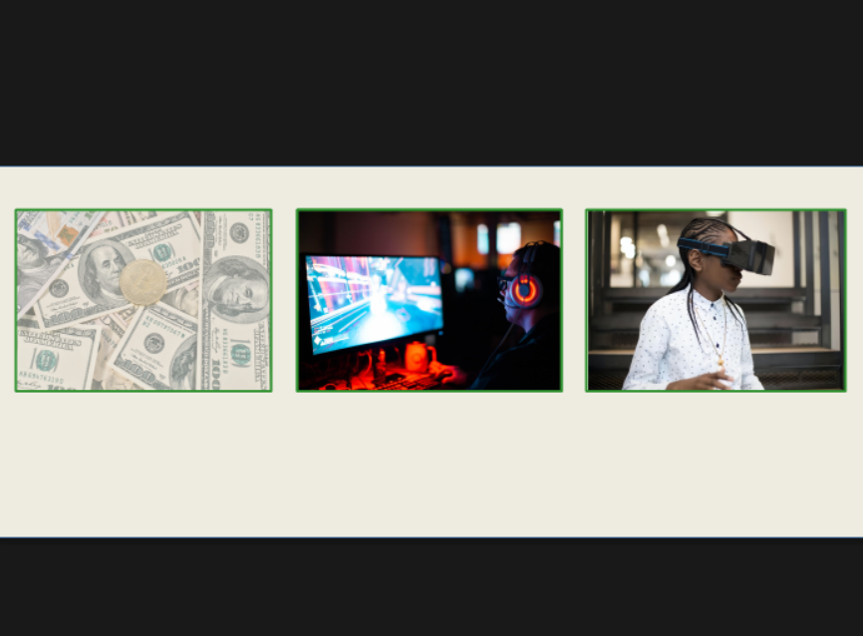 | [1] Use Cases for Digital Currency  [2] Purchases  Opportunities for consumers to use crypto to purchase goods and services are expanding.  [3] Gaming  Play-to-earn gaming enables players to earn crypto as an alternative to earning gaming points.  [4] Metaverse  Acquiring avatars or virtual land is the just beginning of how crypto purchases can predominate in the metaverse. | [1] Investors consider the use cases or function of crypto in their decision-making processes.  [2] Cryptocurrency investors have many options in what they can  [3] Purchases  Just as one would use fiat or paper currency to purchase items, such as cars, electronics, or consumables, or even homes these items could also be purchased with digital currency. Although the prospects are limited, slowly there is a greater availability for consumers to use this as a financial option for purchases.  [4] Gaming  Not only can online games be purchased with cryptocurrency, but many games offer the opportunity to earn crypto as alternative to earning points. Axie Infinity is currently one of the most popular games in what is known as the play-to-earn space.  [5] Metaverse  Individuals can enter augmented realities and virtual worlds. Everything from digital land purchase, gaming, and creating your own avatar are possible with digital currency. The goal of developers is to stay on the cutting edge in this ever-developing speculative digital environment. | Once slide begins, the Use Cases for Digital Currency title (top center of image) appears through use of a motion path.  Three images will appear using fade animation as the narration begins. As each topic is discussed, Purchases, Gaming and Metaverse, the title will appear above each corresponding image in bold lettering.  As the narration continues for each, a text summary will appear below the image followed by the image transitioning into a brief video demonstrating the topic in action. Upon completion of the video loop, the image will reappear as the narrator moves on to the next topic and the rotation will continue in the same format for all three.  Purchase Video  Individual purchasing breakfast items on their phone with bitcoin.  Gaming Video  Individual gaming on their computer  Metaverse Video  Avatar standing in the metaverse with the environment rotating around.  Upon completion, the next button will appear, and the learner will advance to the next slide.
Notes:

Slide [7/ Menu Title: [Facilitating the Purchase of Cryptocurrency] |  |  | Objective: [3-4]
Visual / Display: | Slide Text: | Narration / Voiceover: | Animation / Interaction:
This is the background image for this slide: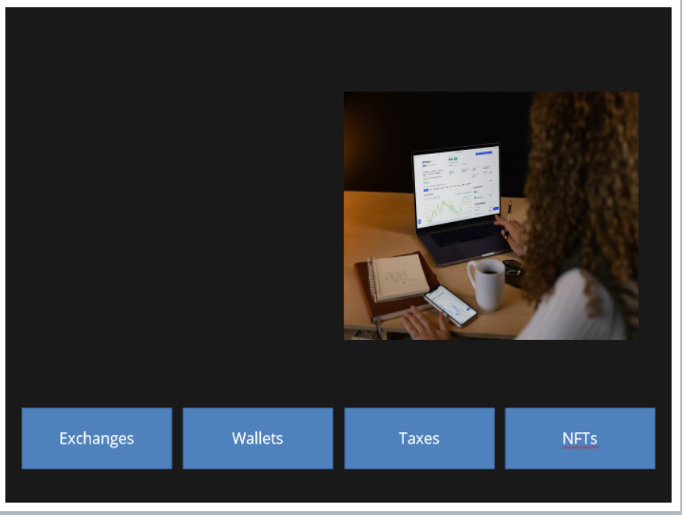  Financial exchanges  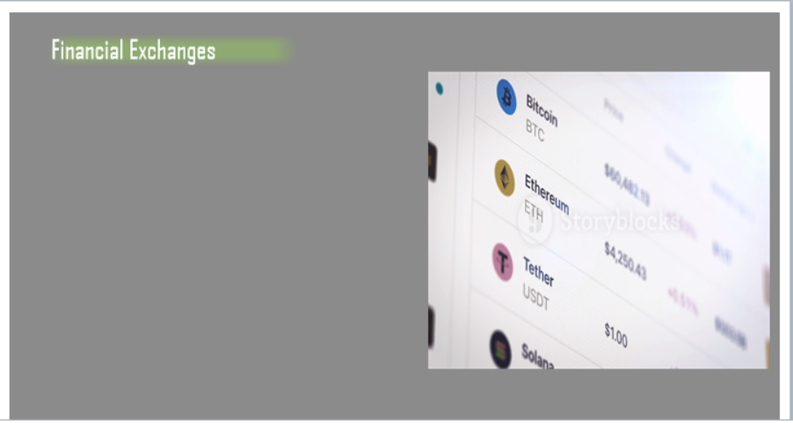  Wallets  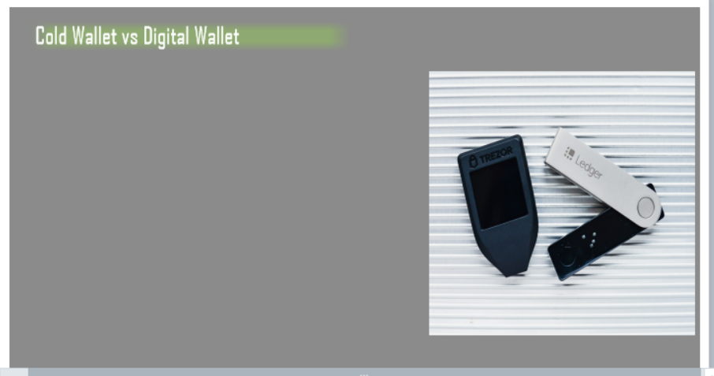  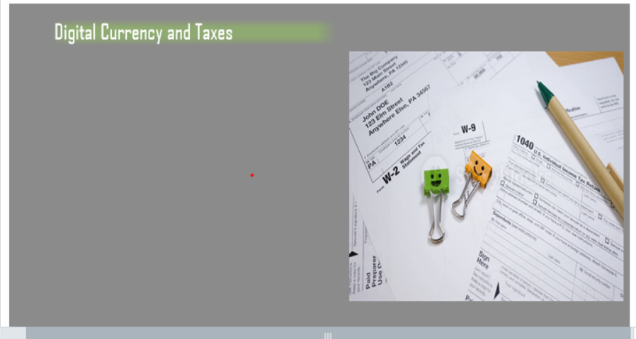Taxes  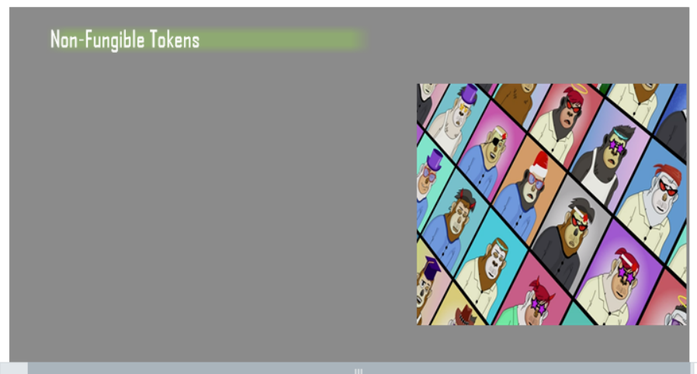  NFTs | [1] Facilitating the Purchase of Cryptocurrency  [Base Layer]  [2] There are many components to how investors purchase, use and store cryptocurrency. The following section will explore the basics of purchases and storage options.  [Exchanges Layer]  [1] Background checks required before opening account  [2] Review rates for digital currency as they fluctuate  [3] There are many ways to purchase cryptocurrency. The options vary from Bitcoin ATMs to online exchanges. A few of the most popular online exchanges, Coinbase, Binance, Kracken and Crypto.com, enable consumers to purchase and sell various digital currencies. Most also offer an online digital wallet option for crypto storage with full ownership rights.  [Wallets Layer]  [1] Cold Wallet vs. Digital Wallet  Cold Wallet  [2] Stores cryptocurrency on a device that is not connected to the Internet.  [3] Connected to a computer through a USB port to transfer funds from an exchange to the device.  [4] They require more intensive steps to secure digital currency.  Digital Wallets  [5] Web 3.0 sites where currency is stored through an online storage server.  [6] Can also be downloaded through apps that are kept on phones for immediate access.  [Marker Text on Image]  Ledger  [1] Ledger is one of the most popular cold wallets on the market. Like the Trezor, a security code, known as security keys, must be created to ensure the safe storge of the currency. The owner usually is the only one who knows the keys and should not share the codes with others to ensure security.  Trezor  [2] Trezor, one of the most trusted cold wallets on the market, enables users to create secure codes to transfer cryptocurrency from online exchanges directly to the device. Minimal fees are incurred when transferring crypto from exchanges to wallets.  [Taxes Layer]  [1] Digital Currency and Taxes  [2] The IRS considers digital currency as a taxable asset if sold or exchanged for a profit.  [3] Transfer of currency to digital wallets is not a taxable event.  [4] If crypto is held for over a year, the holder benefits from long-term capital gains and is taxed less than short term holders.  [5] To exchange one digital currency for another, a sale of the first currency must be made before it is transferred on an exchange as a new sale. This in turn becomes a taxable event. Most online exchanges will provide a printout of all transactions and offer features that can be used to determine tax estimates annually. Transferring tokens from an exchange to a cold wallet is not a taxable event.  [NFT Layer]  Non-Fungible Tokens  [1] NFTs represent real world objects such as art, music, or videos in a digital form.  [2] Acquiring NFTs grants full ownership to the purchaser.  [3] Sales or exchanges are recorded on the blockchain and will appear in owner’s digital wallet, or destination wallet which contains their digital address.  [4] Just like other forms of art, NFT value is determined by the rarity of the NFT to the general value of the collection from which the NFT is derived. The most common Web3 servers for purchasing NFTs are Opensea, Looks Rare and Rariable. NFTs can be sold for a profit but the seller must incur taxes if a profit is made. The online digital wallet Metamask is most commonly used to transact the purchase of NFTs. | [1] Facilitating the Purchase of Cryptocurrency  [Base Layer]  [2] There are many components to how investors purchase, use and store cryptocurrency. The following section will explore the basics of purchases and storage options. Click each tab to learn more.  [Exchanges Layer]  [1] Before creating an account with a cryptocurrency exchange, background checks are required to ensure that illegal trades or money laundering is not taking place.  [2] Once an account is setup, investors have the option to review rates for digital coins. Like stocks, rates fluctuate with market activity.  [Wallets Layer]  [1] Storing digital currency is an important step to ensure that valuable financial assets are safe from hackers and theft.  [2] Cold wallet storage involves storing cryptocurrency on a device that is not connected to the internet.  [3] Cold wallets can connect to a computer through a USB port to transfer funds from an online exchange to the device.  [4] Although cold wallets can be the most secure means of storing digital currency, they require more intensive steps to secure and if not properly stored, can be easily lost or stolen.  [5] Digital wallets are web 3.0 sites where currency is stored through an online storage server. Digital wallets can also be downloaded through apps that are kept on phones for immediate access.  [6] Click on the blue icons to learn more about the Trezor and Ledger cold wallets.  [Taxes Layer]  [1] Taxes play an important role in cryptocurrency transactions.  [2] The IRS considers it a capital asset.  [3] If it is sold or exchanged for a profit, that profit is considered a capital gain.  [4] Losses and gains must be reported.  [5] Transfer of digital currency to wallets is not a taxable event.  [6] Most exchange sites will provide a history of transactions form that can be used when filing taxes.  [7] If crypto is held for over a year, the holder benefits from long-term capital gains and is taxed less than short term holders.  [NFT Layer]  [1] Non-fungible tokens or NFTs are digital assets that represent real-world objects such as art, music, and videos.  [2] They are stored as digital tokens.  [3] Often confused as JPEGS, they are tokenized cryptocurrency.  [4] Purchasing NFTs grants the purchaser full ownership of the digital art as it cannot be duplicated.  [5] Sales and purchases are recorded on the blockchain, and the owner is identified by their public digital wallet address.  [6] The address is a series of alphanumeric representing the person’s financial transaction address on the blockchain.  [7] This is also known as a destination wallet. | Once slide begins, the Facilitating the Purchase of Cryptocurrency title (top center of image) appears in a static format along with the image and text.  Each blue tab has a hover spot so the learner can select a tab to advance to each layer. Each layer has a video image that runs while the audio plays in the background. Key information from the audio appears using fade animation and remains for the duration of the slide.  The wallets tab will have the trigger for hide text at the end of the narration so the learner can select one of two hover spots on the image of the Ledger and Trezor wallets to learn more about the storage options.  Upon completion, the next button will appear, and the learner will advance to the next slide.
Notes:

Slide [8]/ Menu Title: [End of eLearning Module Slide] |  |  | Objective: [#]
Visual / Display: | Slide Text: | Narration / Voiceover: | Animation / Interaction:
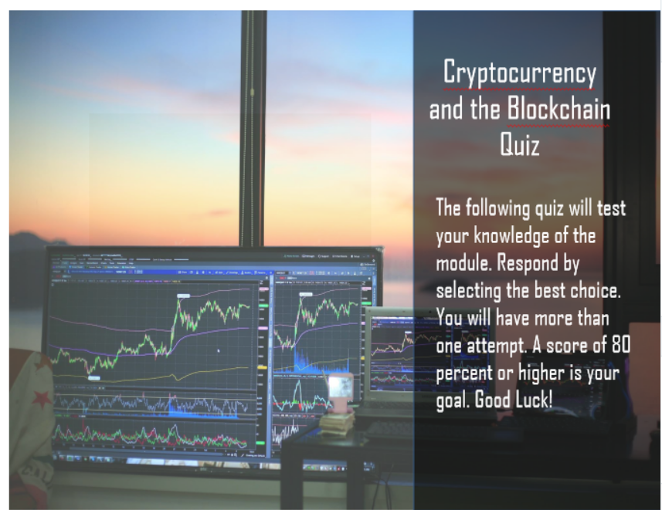 | [1] Cryptocurrency and the blockchain quiz  [2] The following quiz will test your knowledge of the module. Respond by selecting the best choice. You will have more than one attempt. A score of 80 percent or higher is your goal. Good Luck! | [1] The following quiz will test your knowledge of the module. Respond by selecting the best choice. You will have more than one attempt. A score of 80 percent or higher is your goal. Good Luck! | Slide with transparency adjustment and fade in words.  Select next button to continue
Notes:

Scene 2 Assessment
Slide [9.1]/ Menu Title: [Assessment Question 1] |  |  | Objective: [3]
Visual / Display: | Slide Text: | Narration / Voiceover: | Animation / Interaction:
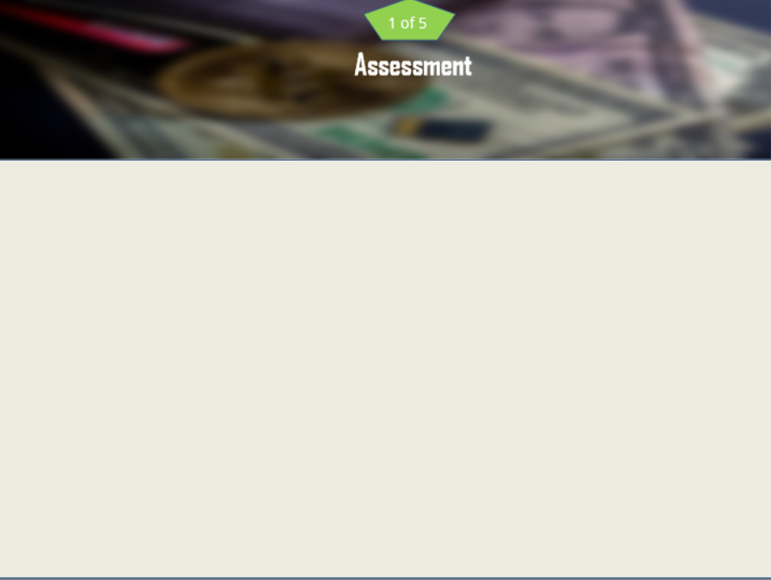 | Assessment  1.The most secure way to store cryptocurrency is through:  a) online exchanges  b) banks  c) the blockchain  d) cold wallets | Once again, it’s time to practice your skills by applying what you’ve learned in this end of module assessment. Read each question and select the best answer choice. | Learner will select the best answer choice on this static slide.  Upon completion, the next button will appear, and the learner will advance to the next slide.
Notes:

Slide [9.2]/ Menu Title: [Assessment Question 2] |  |  | Objective: [4]
Visual / Display: | Slide Text: | Narration / Voiceover: | Animation / Interaction:
 | Assessment  2.Which is considered a taxable event for digital currency transactions?  a) purchasing  b) trading  c) transferring currency from an exchange to a cold wallet  d) both trading and selling cryptocurrency |  | Learner will select the best answer choice on this static slide.  Upon completion, the next button will appear, and the learner will advance to the next slide.
Notes:

Slide [9.3]/ Menu Title: [Assessment Question 3] |  |  | Objective: [2]
Visual / Display: | Slide Text: | Narration / Voiceover: | Animation / Interaction:
 | Assessment  3.NFTs are digital art that:  a) are JPEGS and can be purchased with cryptocurrency  b) are digital tokens that cannot be transacted on the blockchain  c) can increase in value depending on the popularity and the value of the collection from which it derives  d) cannot be bought or sold | . | Learner will select the best answer choice on this static slide.  Upon completion, the next button will appear, and the learner will advance to the next slide.
Notes:

Slide [9.4]/ Menu Title: [Assessment Question 4] |  |  | Objective: [#]
Visual / Display: | Slide Text: | Narration / Voiceover: | Animation / Interaction:
 | Assessment  4.Cryptocurrency is digital currency where transactions are stored:  a) through paper ledgers  b) centrally through online banks  c) through a decentralized digital ledger called the blockchain  d) in a bank vault |  | Learner will select the best answer choice on this static slide.  Upon completion, the next button will appear, and the learner will advance to the next slide.
Notes:

Slide [9.5]/ Menu Title: [Assessment Question 5] |  |  | Objective: [#]
Visual / Display: | Slide Text: | Narration / Voiceover: | Animation / Interaction:
 | Assessment  5.Which digital token was the first form of cryptocurrency designed for the storage of wealth?  a) Cardano  b) Ethereum  c) bitcoin  d) mana |  | Learner will select the best answer choice on this static slide.  Upon completion, the next button will appear, and the learner will advance to the next slide.
Notes:

Slide [9.6]/ Menu Title: [Assessment Score Tabulation/Assessment Results Slide] |  |  | Objective: [#]
Visual / Display: | Slide Text: | Narration / Voiceover: | Animation / Interaction:
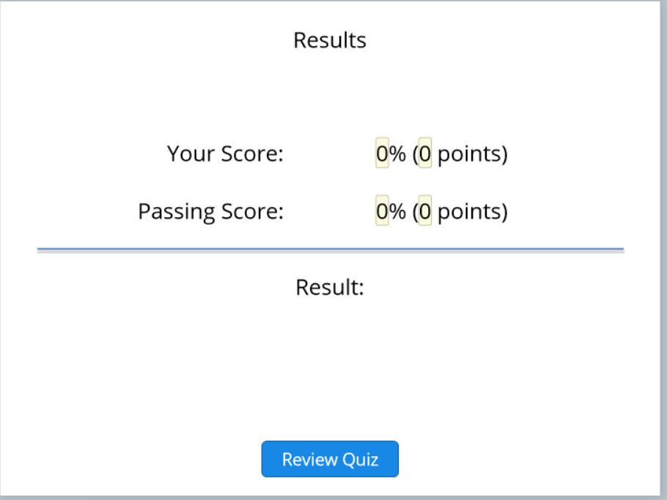 | Results  Your Score  Passing Score  Result  Review Quiz | [1] Good job.  [2] Here are the results of your efforts.  [3] Select the review quiz button to review your responses.  [4] Select the next button to advance to the next slide. | Learner’s score will be tabulated and there will be a button with hover spot for learner to click to review their responses.  Upon completion, the next button will appear, and the learner will advance to the next slide.
Notes:

Slide [10]/ Menu Title: [Assessment Congratulations Slide] |  |  | Objective: [#]
Visual / Display: | Slide Text: | Narration / Voiceover: | Animation / Interaction:
 | Great job of testing your knowledge!  Scoring at least 80 percent on the knowledge check questions will enable you to conclude this module. Please repeat any section of this module if your score is lower than 80 percent. | [1] Great job of testing your knowledge!  [2] Scoring at least 80 percent on the knowledge check questions will enable you to conclude this module.  [3] Please repeat any section of this module if your score is lower than 80 percent.  [4] Select the next button to continue. | Static slide with transparency adjustment.  Upon completion, the next button will appear, and the learner will advance to the next slide.
Notes:

Slide [11]/ Menu Title: [Cryptocurrency and the Blockchain Summary Slide] |  |  | Objective: [1-4]
Visual / Display: | Slide Text: | Narration / Voiceover: | Animation / Interaction:
 | [1] Why consider digital currency as a financial asset?  [2] Viable option for investors to create and build wealth.  [3] Seen by investors as the currency of the future.  [4] A value that has yet to be determined.  [5] Speculative nature of the tokens make it a commodity. | [1] Why consider digital currency as a financial asset?  [2] Viable option for investors to create and build wealth. Although only 100 million individuals around the world are interacting with digital currency, the numbers are increasing as investors and corporations are seeing it’s potential for growth. Just like the development of the internet in the 1990s  Cryptocurrency is [3] viewed as the currency of the future.  With [4] A value that has yet to be determined.  It is the [5] Speculative nature of the tokens make it an intriguing commodity.  [6] Select next to continue | A looping video of a technology web will appear upon the opening of the slide, a motion path will bring in the title of the slide to the center, why consider digital currency as a financial asset.  Four (4) sections of the image will slide in alignment with the narration until complete image is made. Under each image will appear a summarized sentence of each aspect of the narration.  Upon completion, the next button will appear, and the learner will advance to the next slide.
Notes:

Slide [12]/ Menu Title: [End of eLearning Module Slide] |  |  | Objective: [#]
Visual / Display: | Slide Text: | Narration / Voiceover: | Animation / Interaction:
 | Congratulations  [1] You have completed the course!  [2] Exit Tab | Congratulations  Congratulations on a job well done![1] You have successfully completed the introduction to digital currency and the blockchain course.  {2} You may select the exit tab to close the eLearning module. | Slide with transparency adjustment and fade in words.  Upon completion, the learner can close the module.
Notes:

